Maven
# Source: AI Source: Provided by: [Data Path: Persons Table -> ID Column: 1, Name_En Column: Motasem Essam] -> From: [ChatGPT] on [1/26/2026]
Maven is a dependency manager and build automation tool for Java projects.
It helps developers compile, build, test, and manage dependencies in a consistent and automated way.

Key Features of Maven
# Source: AI Source: Provided by: [Data Path: Persons Table -> ID Column: 1, Name_En Column: Motasem Essam] -> From: [ChatGPT] on [1/26/2026]
- Dependency Management
  - Automatically downloads the libraries (JAR files) your project needs.
  - Resolves transitive dependencies (libraries that your libraries depend on).
- Build Automation
  - Compiles Java code, runs tests, packages into JAR/WAR files, and deploys.
- Standard Project Structure
  - Encourages a consistent directory layout (src/main/java, src/test/java).
- Project Metadata
  - Uses a pom.xml file to define the project, dependencies, and build instructions.

pom.xml (Project Object Model)
# Source: AI Source: Provided by: [Data Path: Persons Table -> ID Column: 1, Name_En Column: Motasem Essam] -> From: [ChatGPT] on [1/26/2026]
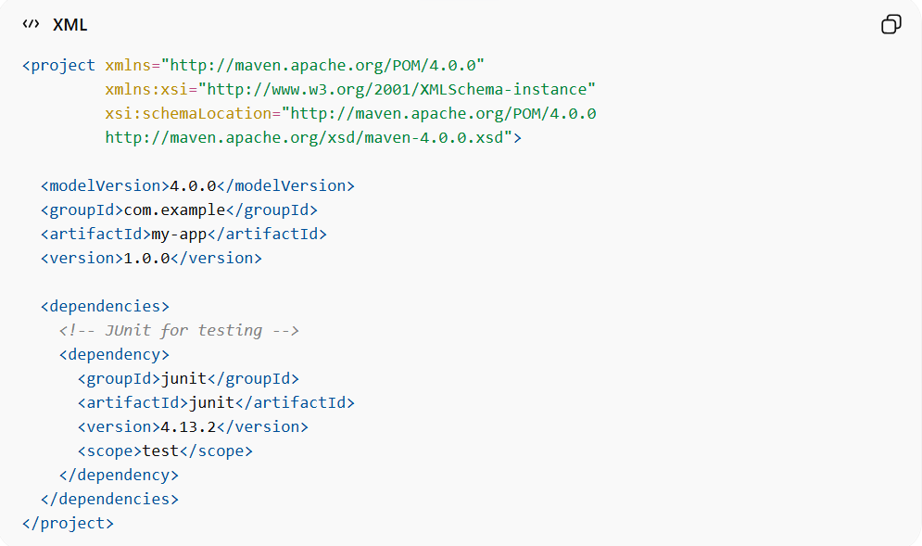
This is the main file Maven uses for configuration.
<project xmlns="http://maven.apache.org/POM/4.0.0"
xmlns:xsi="http://www.w3.org/2001/XMLSchema-instance"
xsi:schemaLocation="http://maven.apache.org/POM/4.0.0
http://maven.apache.org/xsd/maven-4.0.0.xsd">

<modelVersion>4.0.0</modelVersion>
<groupId>com.example</groupId>
<artifactId>my-app</artifactId>
<version>1.0.0</version>

<dependencies>
<!-- JUnit for testing -->
<dependency>
<groupId>junit</groupId>
<artifactId>junit</artifactId>
<version>4.13.2</version>
<scope>test</scope>
</dependency>
</dependencies>
</project>
Sure! Let’s break down the Maven pom.xml snippet line by line so you understand what each part does.

1️⃣ <project> element
# Source: AI Source: Provided by: [Data Path: Persons Table -> ID Column: 1, Name_En Column: Motasem Essam] -> From: [ChatGPT] on [1/26/2026]
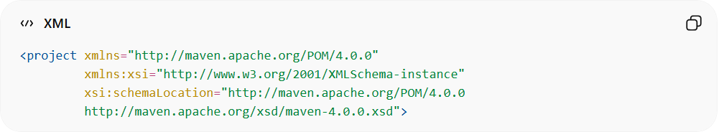
<project xmlns="http://maven.apache.org/POM/4.0.0"
xmlns:xsi="http://www.w3.org/2001/XMLSchema-instance"
xsi:schemaLocation="http://maven.apache.org/POM/4.0.0
http://maven.apache.org/xsd/maven-4.0.0.xsd">
- This is the root element of a Maven POM (Project Object Model).
- xmlns and xsi:schemaLocation define the XML namespaces and schema, which tells Maven how to read and validate the file.
- Every pom.xml starts with this <project> tag.

2️⃣ <modelVersion>
# Source: AI Source: Provided by: [Data Path: Persons Table -> ID Column: 1, Name_En Column: Motasem Essam] -> From: [ChatGPT] on [1/26/2026]
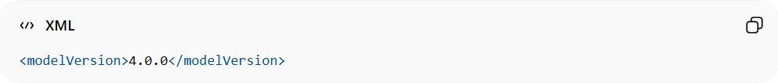
<modelVersion>4.0.0</modelVersion>
- Specifies the POM model version Maven should use.
- Usually, 4.0.0 is standard for all modern Maven projects.

3️⃣ Project coordinates
# Source: AI Source: Provided by: [Data Path: Persons Table -> ID Column: 1, Name_En Column: Motasem Essam] -> From: [ChatGPT] on [1/26/2026]
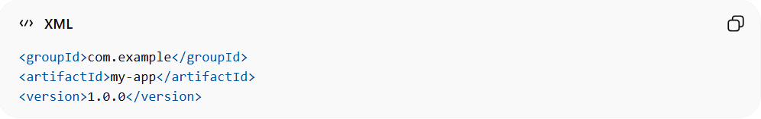
<groupId>com.example</groupId>
<artifactId>my-app</artifactId>
<version>1.0.0</version>
These define the identity of your project in Maven’s ecosystem:
- groupId – Typically your organization or package structure (like a namespace).
  - Example: com.example
- artifactId – The project name or module name.
  - Example: my-app
- version – The version of your project.
  - Example: 1.0.0
Together, these three are called GAV coordinates (Group, Artifact, Version).

4️⃣ <dependencies> section
# Source: AI Source: Provided by: [Data Path: Persons Table -> ID Column: 1, Name_En Column: Motasem Essam] -> From: [ChatGPT] on [1/26/2026]
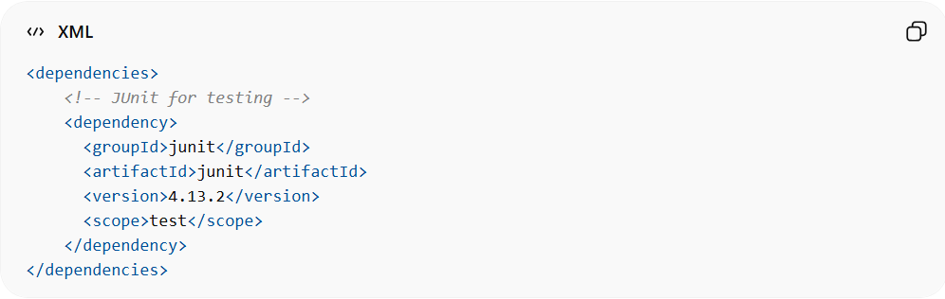
<dependencies>
<!-- JUnit for testing -->
<dependency>
<groupId>junit</groupId>
<artifactId>junit</artifactId>
<version>4.13.2</version>
<scope>test</scope>
</dependency>
</dependencies>
This section lists all external libraries your project needs:
- <dependency> – Each library is defined inside a <dependency> block.
- groupId – Library’s organization or package.
  - Example: junit
- artifactId – The specific library/module name.
  - Example: junit
- version – The exact version of the library to use.
  - Example: 4.13.2
- scope – Defines when the dependency is needed:
  - compile → needed to build/run the app (default)
  - test → needed only for testing
  - provided → available in runtime environment, but not packaged
In this example, JUnit is a test-only dependency, so it won’t be included in the final JAR.

5️⃣ Closing </project>
# Source: AI Source: Provided by: [Data Path: Persons Table -> ID Column: 1, Name_En Column: Motasem Essam] -> From: [ChatGPT] on [1/26/2026]
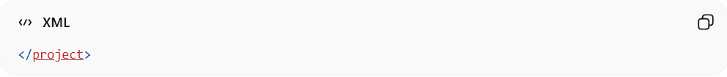
</project>
- Ends the root <project> tag.
- Everything about the project (metadata, dependencies, build info) goes inside this tag.

✅ Summary
# Source: AI Source: Provided by: [Data Path: Persons Table -> ID Column: 1, Name_En Column: Motasem Essam] -> From: [ChatGPT] on [1/26/2026]
- <project> – Root of Maven configuration.
- <modelVersion> – Version of POM schema.
- GAV coordinates (groupId, artifactId, version) – Unique identity of your project.
- <dependencies> – Lists libraries your project needs, with versions and scopes.

final JAR
# Source: AI Source: Provided by: [Data Path: Persons Table -> ID Column: 1, Name_En Column: Motasem Essam] -> From: [ChatGPT] on [1/26/2026]
A final JAR is the compiled output of a Java project packaged into a JAR file that you can run or distribute. Let me break it down:

1️⃣ What is a JAR?
# Source: AI Source: Provided by: [Data Path: Persons Table -> ID Column: 1, Name_En Column: Motasem Essam] -> From: [ChatGPT] on [1/26/2026]
- JAR = Java ARchive
- It’s like a ZIP file that contains:
  - Your compiled .class files (Java bytecode)
  - Resources like images, configuration files
  - Optional metadata (like MANIFEST.MF)
- Example:
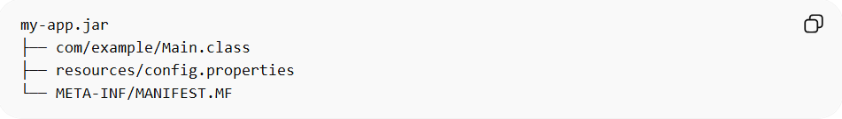
my-app.jar
├── com/example/Main.class
├── resources/config.properties
└── META-INF/MANIFEST.MF

2️⃣ What does “final JAR” mean?
# Source: AI Source: Provided by: [Data Path: Persons Table -> ID Column: 1, Name_En Column: Motasem Essam] -> From: [ChatGPT] on [1/26/2026]
- Final JAR is the complete packaged application after all code is compiled and dependencies are included (or referenced).
- It’s the artifact that Maven or Gradle produces when you run commands like:
- mvn package # Maven
- gradle build # Gradle
- If it’s a “fat” or “uber” JAR, it may include all dependencies inside so you can run it without separately installing libraries.

3️⃣ Example Use
# Source: AI Source: Provided by: [Data Path: Persons Table -> ID Column: 1, Name_En Column: Motasem Essam] -> From: [ChatGPT] on [1/26/2026]
- You write a Java program:
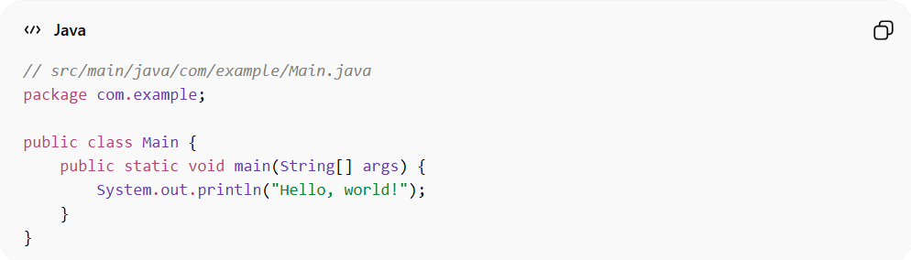
// src/main/java/com/example/Main.java
package com.example;

public class Main {
public static void main(String[] args) {
System.out.println("Hello, world!");
}
}
- Compile & package with Maven:
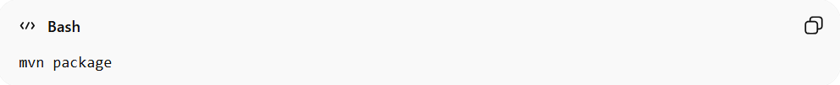
mvn package
- Maven produces:
target/my-app-1.0.0.jar
- Run the final JAR:
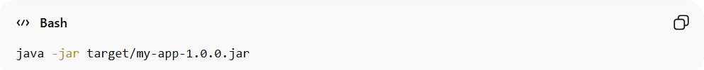
java -jar target/my-app-1.0.0.jar
Output:
Hello, world!

✅ Summary
- JAR = Java archive (like ZIP of compiled code + resources)
- Final JAR = The ready-to-use compiled package of your application
- Produced by Maven, Gradle, or other build tools
- Can be run, shared, or deployed

manifest file
# Source: AI Source: Provided by: [Data Path: Persons Table -> ID Column: 1, Name_En Column: Motasem Essam] -> From: [ChatGPT] on [1/26/2026]
In Java, the manifest file is a special metadata file inside a JAR that tells the Java Virtual Machine (JVM) important information about the JAR and how to run it.

1️⃣ Location
# Source: AI Source: Provided by: [Data Path: Persons Table -> ID Column: 1, Name_En Column: Motasem Essam] -> From: [ChatGPT] on [1/26/2026]
- It’s always located in:
META-INF/MANIFEST.MF
- Every JAR has a META-INF folder, and MANIFEST.MF is a plain text file inside it.

2️⃣ Purpose
# Source: AI Source: Provided by: [Data Path: Persons Table -> ID Column: 1, Name_En Column: Motasem Essam] -> From: [ChatGPT] on [1/26/2026]
The manifest file can include:
- Main class – which class contains the main method to run:
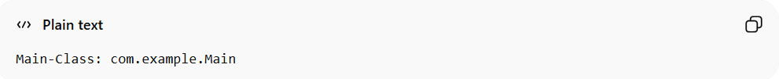
Main-Class: com.example.Main
- Version information – version of the JAR:
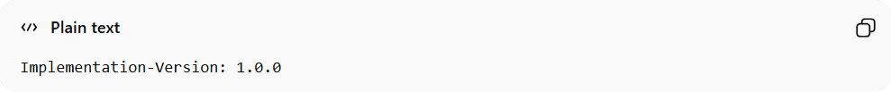
Implementation-Version: 1.0.0
- Sealed packages, classpath, and other metadata – used by JVM or tools.

3️⃣ Example MANIFEST.MF
# Source: AI Source: Provided by: [Data Path: Persons Table -> ID Column: 1, Name_En Column: Motasem Essam] -> From: [ChatGPT] on [1/26/2026]
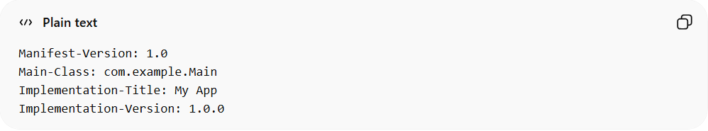
Manifest-Version: 1.0
Main-Class: com.example.Main
Implementation-Title: My App
Implementation-Version: 1.0.0
The key part for running a JAR is Main-Class. Without it, you can’t run the JAR using java -jar my-app.jar.

4️⃣ How it Works
# Source: AI Source: Provided by: [Data Path: Persons Table -> ID Column: 1, Name_En Column: Motasem Essam] -> From: [ChatGPT] on [1/26/2026]
- You compile your Java project:
javac -d out src/com/example/Main.java
- Package into a JAR with a manifest:
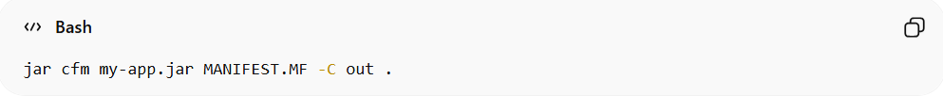
jar cfm my-app.jar MANIFEST.MF -C out .
- Run the JAR:
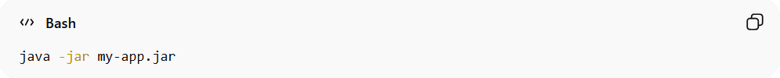
java -jar my-app.jar
- JVM reads MANIFEST.MF to find which class has main().

✅ Summary
- Manifest file = metadata inside JAR (META-INF/MANIFEST.MF)
- Defines main class, version, and other info
- Required if you want to run a JAR with java -jar

If you want, I can also draw a simple diagram showing how a JAR, classes, resources, and MANIFEST.MF are organized, which makes it easy to remember.
Do you want me to do that?

Common Maven Commands
# Source: AI Source: Provided by: [Data Path: Persons Table -> ID Column: 1, Name_En Column: Motasem Essam] -> From: [ChatGPT] on [1/26/2026]
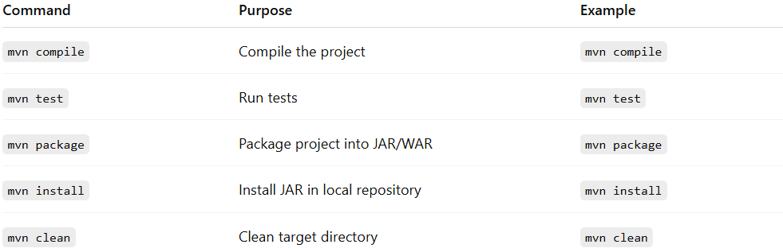
Command | Purpose | Example
mvn compile | Compile the project | mvn compile
mvn test | Run tests | mvn test
mvn package | Package project into JAR/WAR | mvn package
mvn install | Install JAR in local repository | mvn install
mvn clean | Clean target directory | mvn clean

✅ Summary
# Source: AI Source: Provided by: [Data Path: Persons Table -> ID Column: 1, Name_En Column: Motasem Essam] -> From: [ChatGPT] on [1/26/2026]
- Maven = Java dependency manager + build tool
- Uses pom.xml to define dependencies, project structure, and build steps
- Automatically manages dependencies and builds in a consistent way

